1.Zwitter ion
2.Discuss chemical structure of protein.
3.Discuss functions of Protein
4.What is protein catabolism and metabolism
5Discuss 5 methods for the preparation of alkane

- Discuss following reactions:
7Hydrohalogenation of alkene
8Hydration of ethanol
9Oxidation of ethene with cold, dilute KMnO4
10Oxidation of propene with hot, conc KMnO4 and ozone
11Dehydrohalogenation of bromoethane
12Hydroboration oxidation of propyne
13Reaction of propyne with sodium amide
14electrical double layer,
15Tyndal effect,
16Brownian movement,
17coagulation of colloids,
18colloids-defination,
19disperse phase and dispersion medium,
20lyophilic and lyophobic colloids,
21Bredig's Arc method

Ans
    - 1]DISPERSION MEDIUM
- Definition: The disperse phase is the substance that is distributed in the form of small particles throughout the dispersion medium.
- The dispersion medium is the phase in which the colloidal particles are suspended or dispersed.

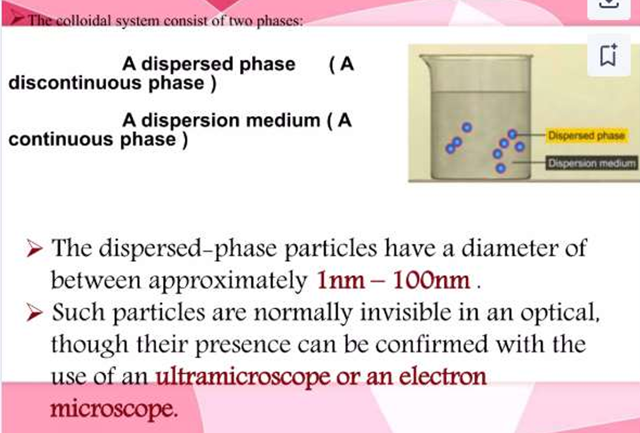

2]
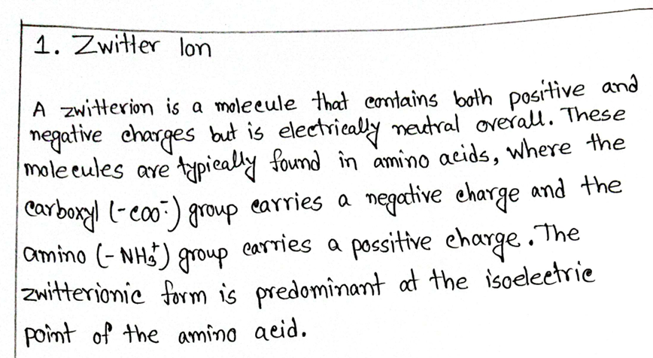
3]LYOPHIBIC
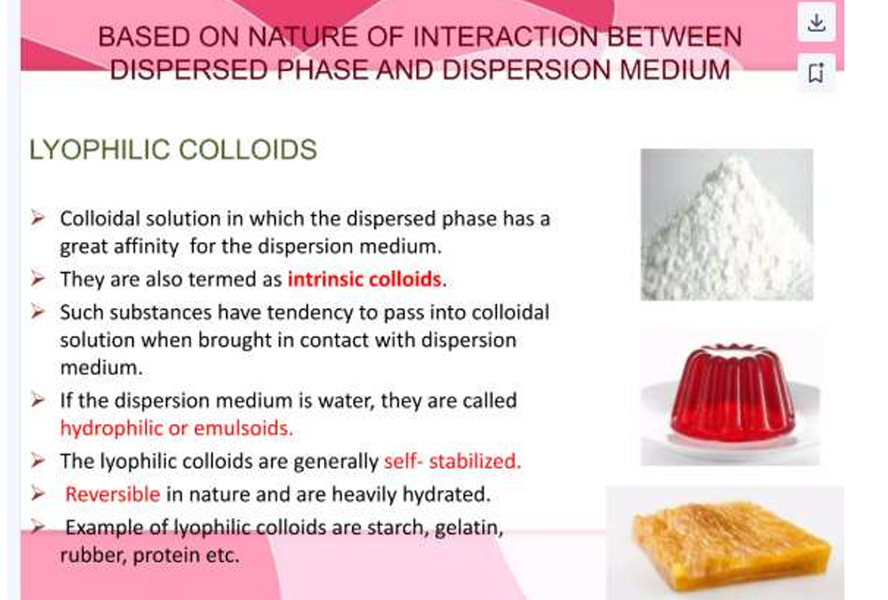
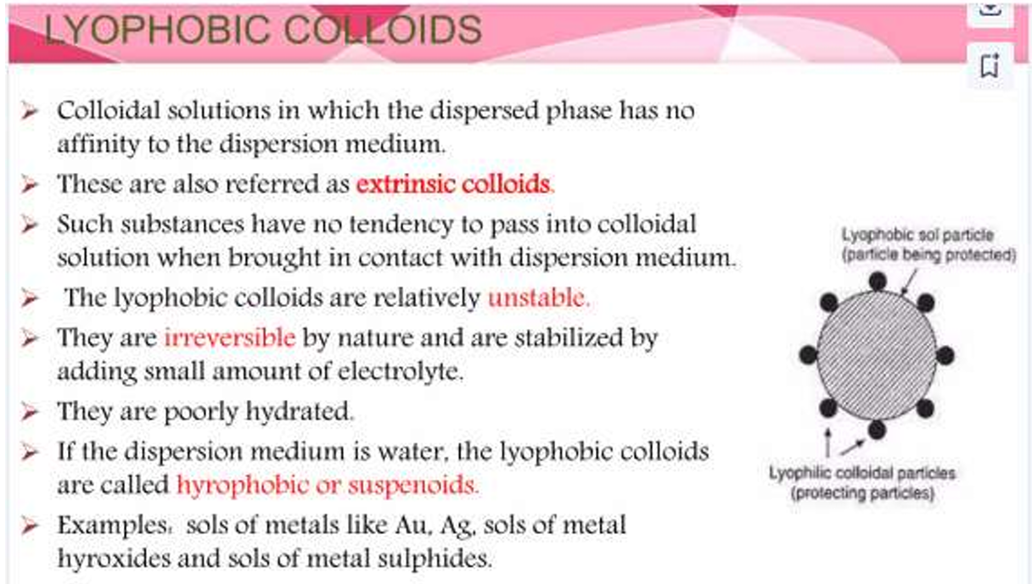
4]
By Electrical Dispersion or Bredig’s Arc Method
- This method is used to prepare sols of platinum, silver, copper, or gold.
- The metal whose sol is to be prepared is made as two electrodes which immerse in a dispersion medium such as water, etc.
- The dispersion medium is kept cooled by ice.
- An electric arc is struck between the electrodes.
- The tremendous heat generated by this method gives a colloidal solution.
- The colloidal solution prepared is stabilized by adding a small amount of KOH to it.
5] 
6] 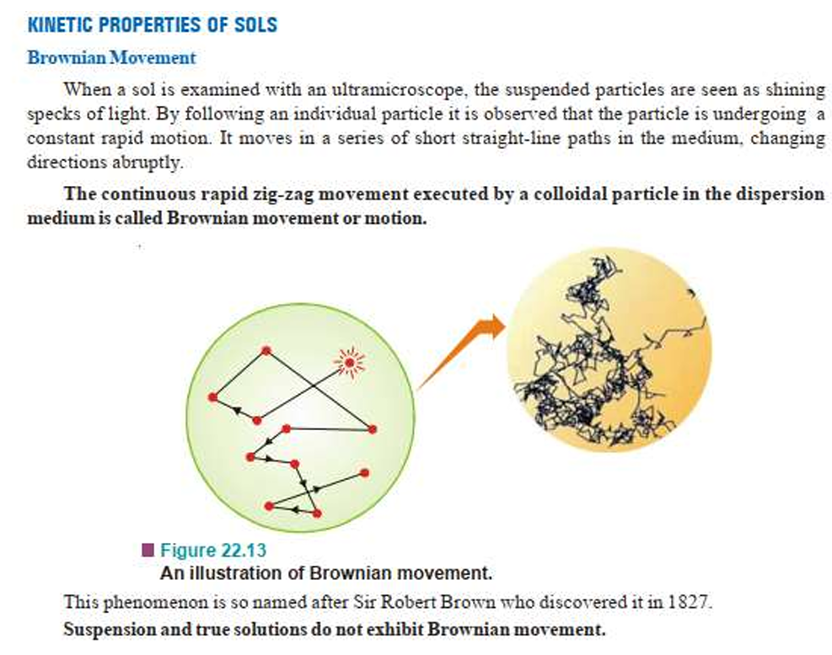

7]
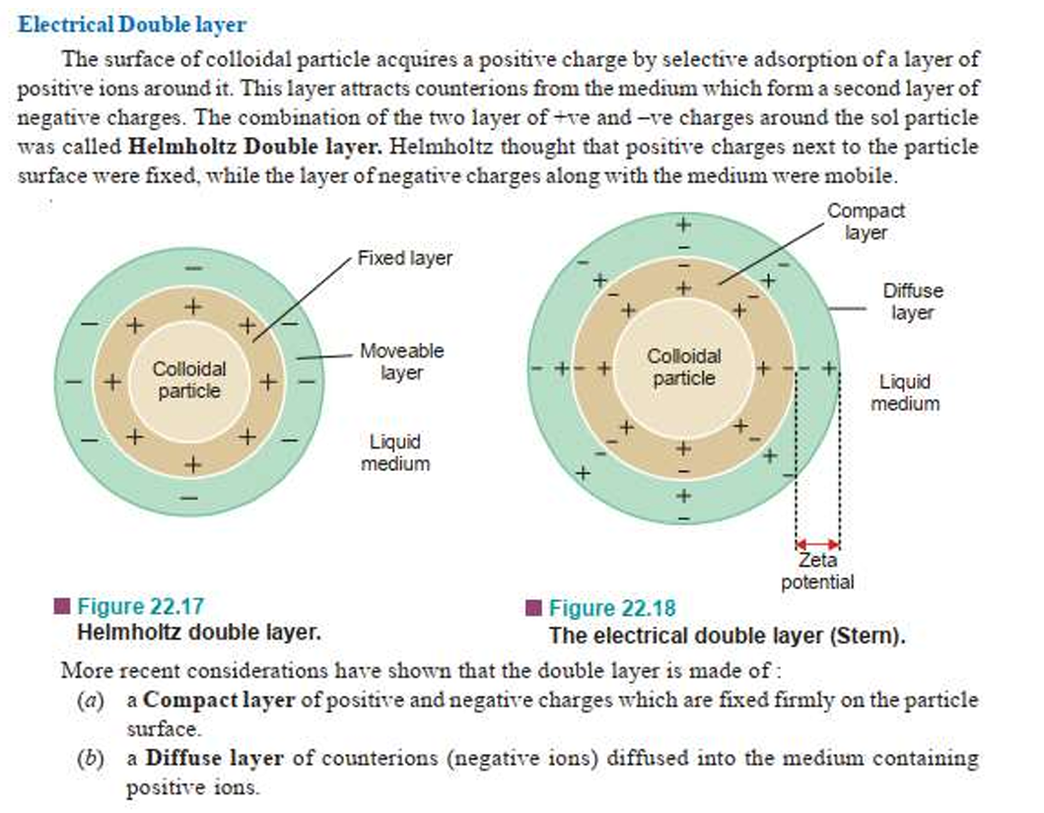
8] 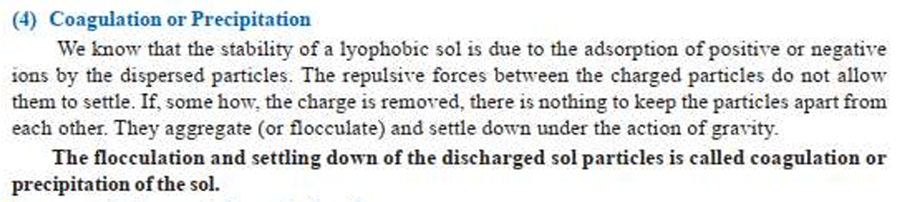
9] 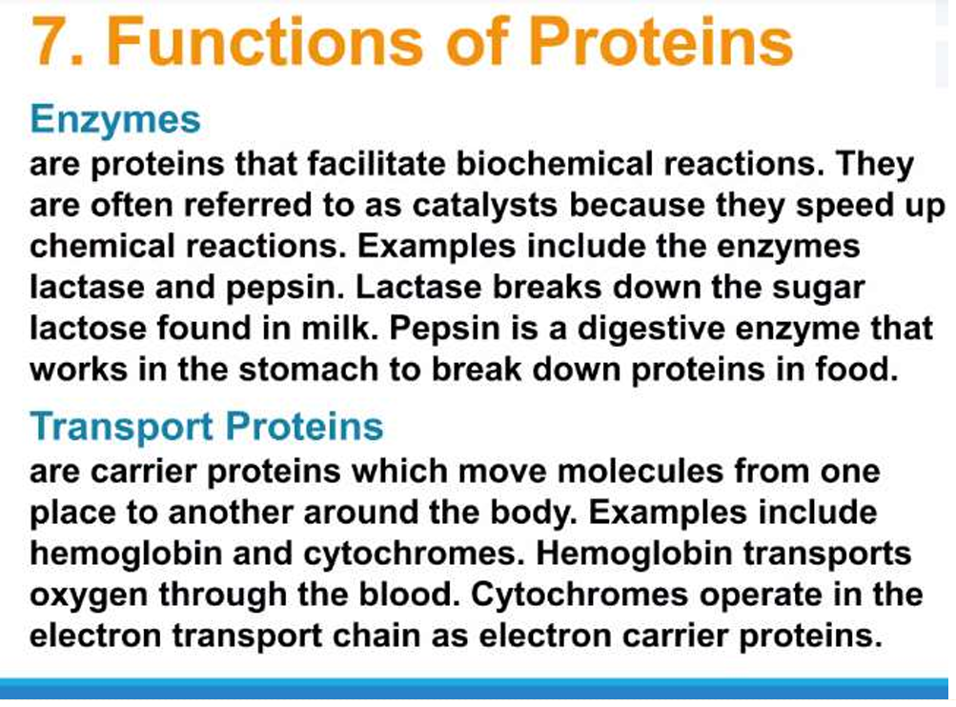

10]
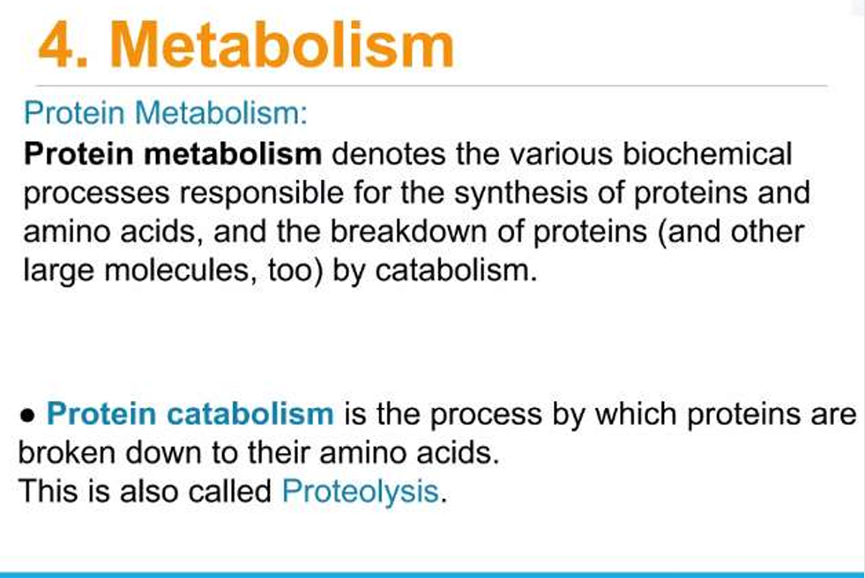
11]
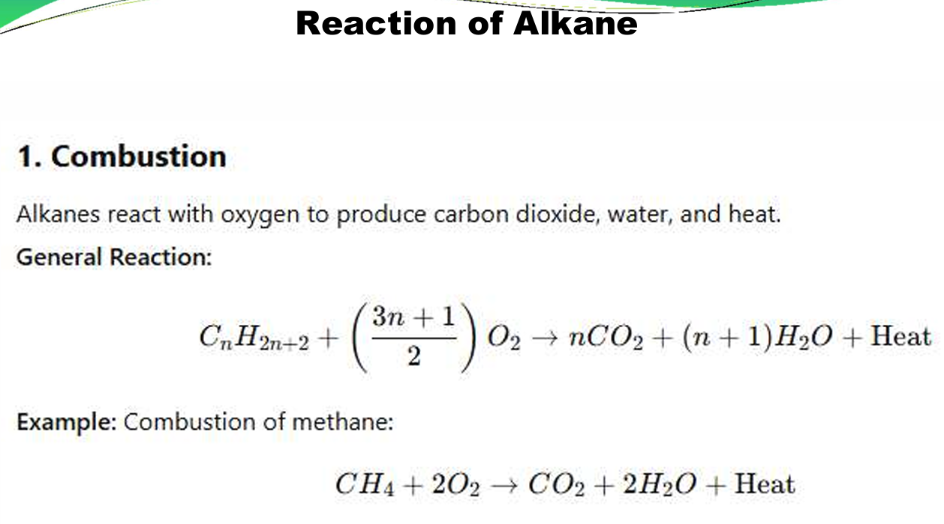
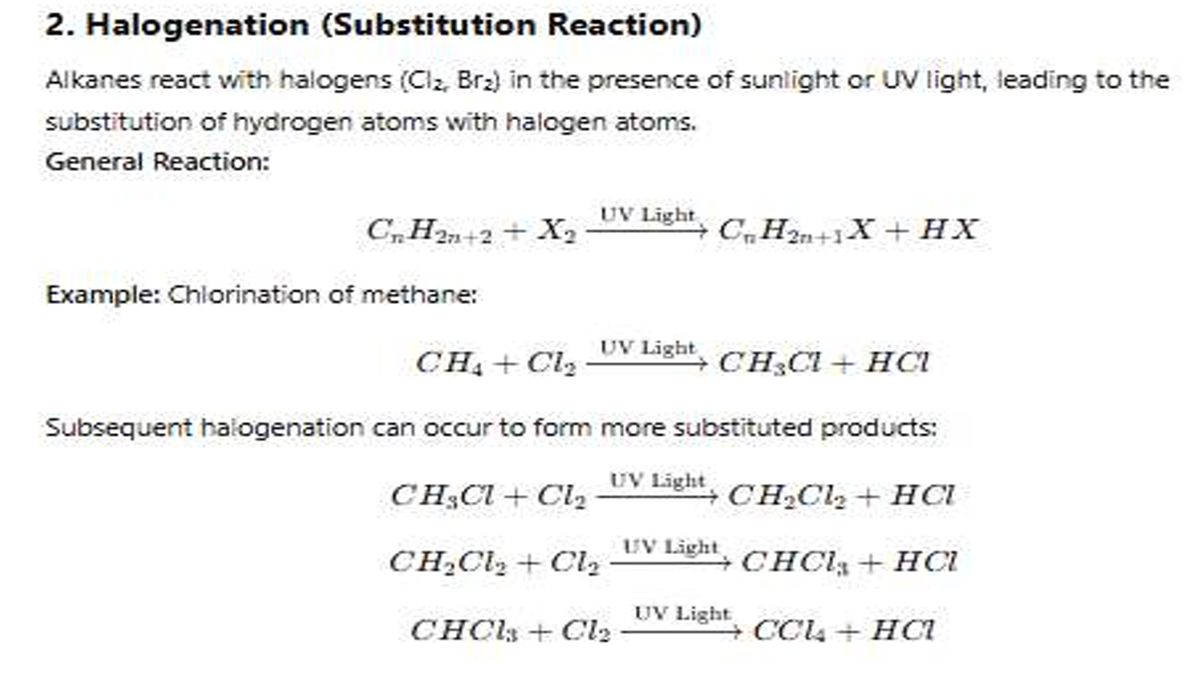
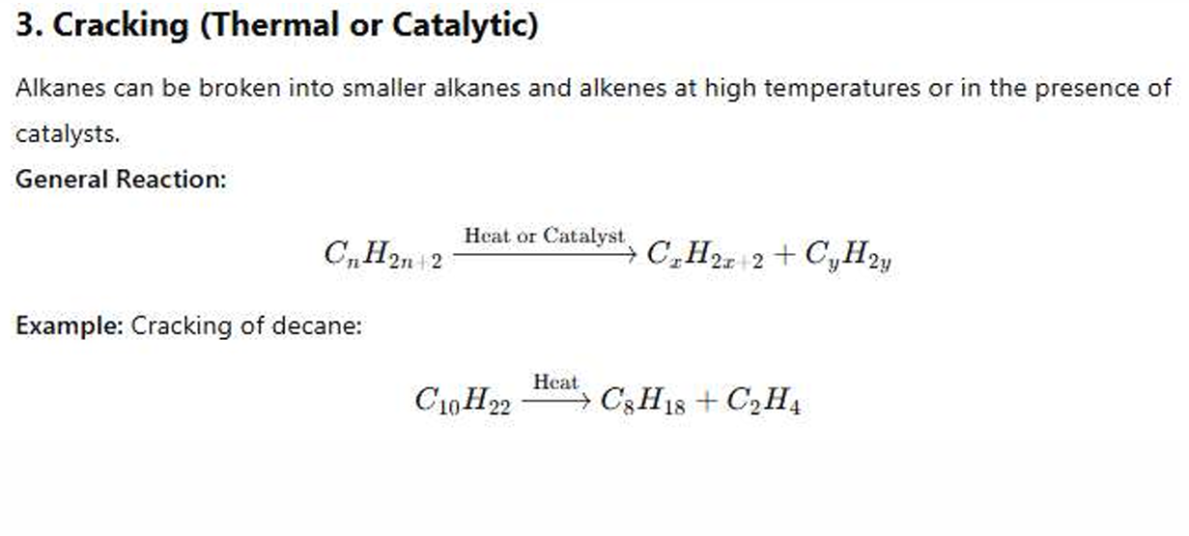
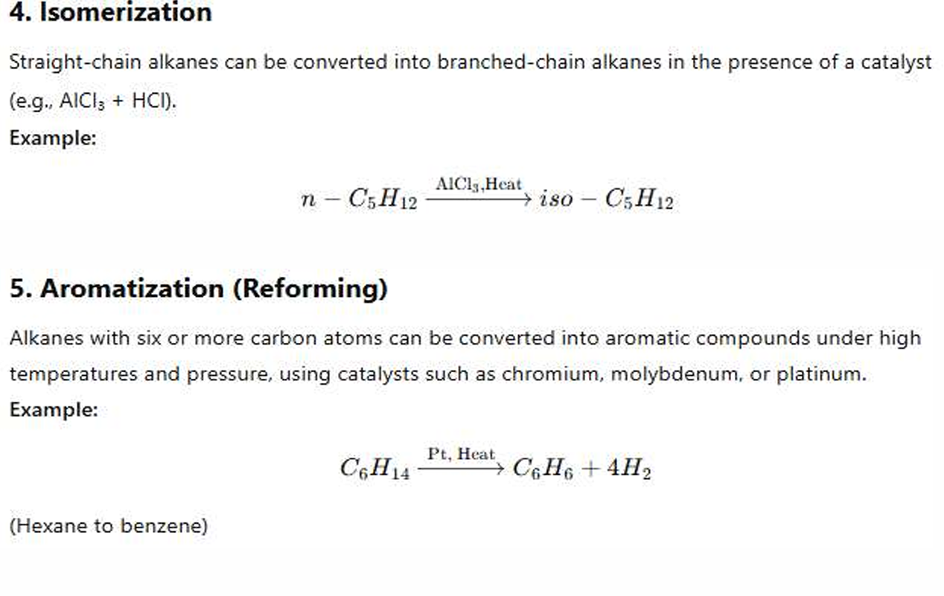
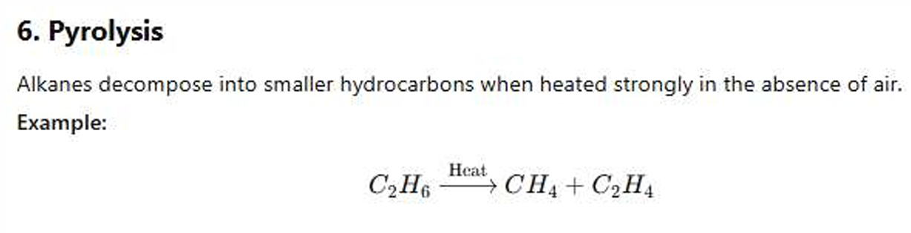
11111] 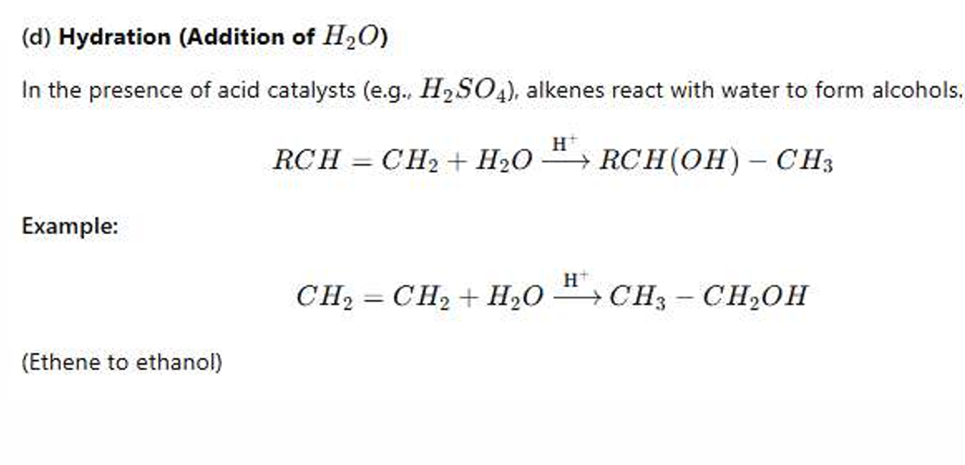
12]
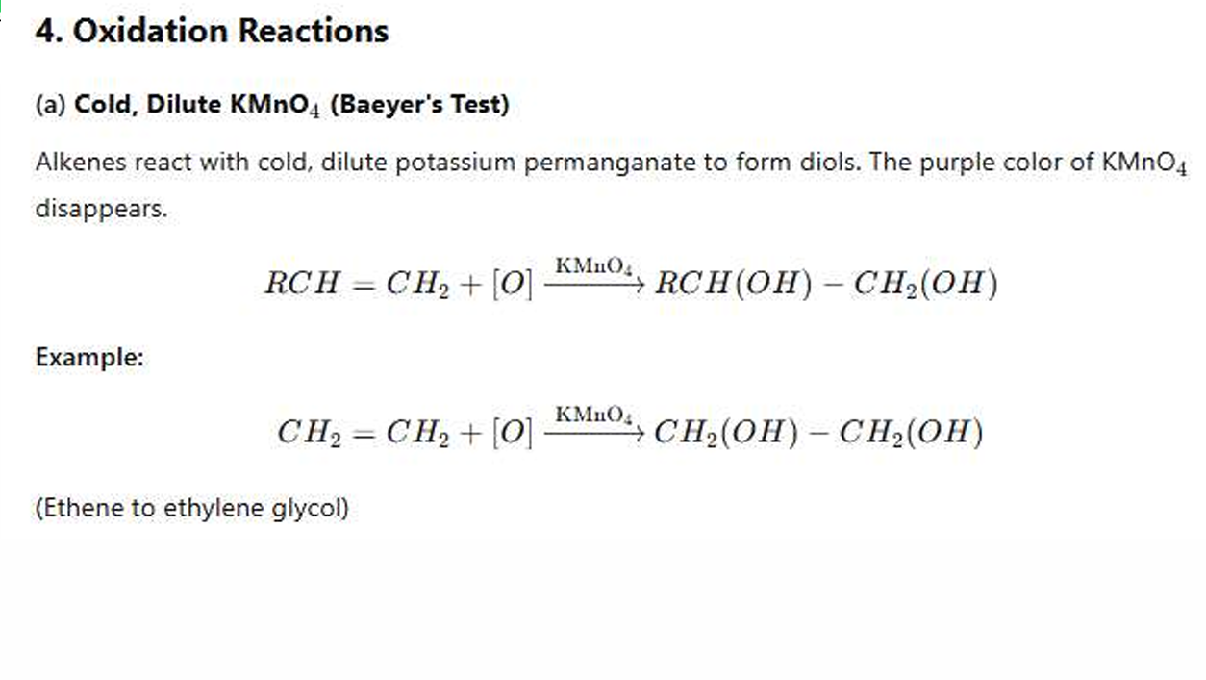
13]
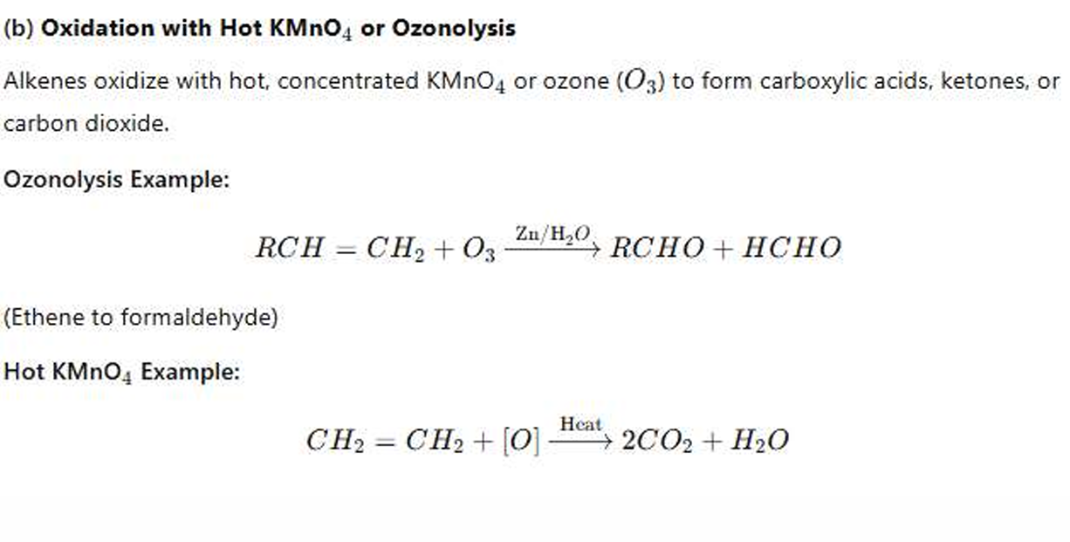
14] 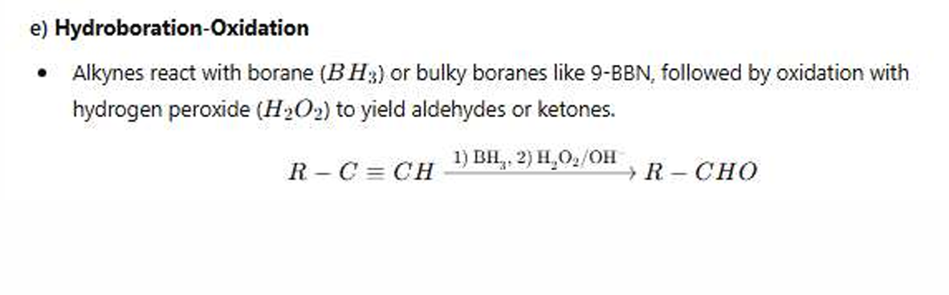

15]
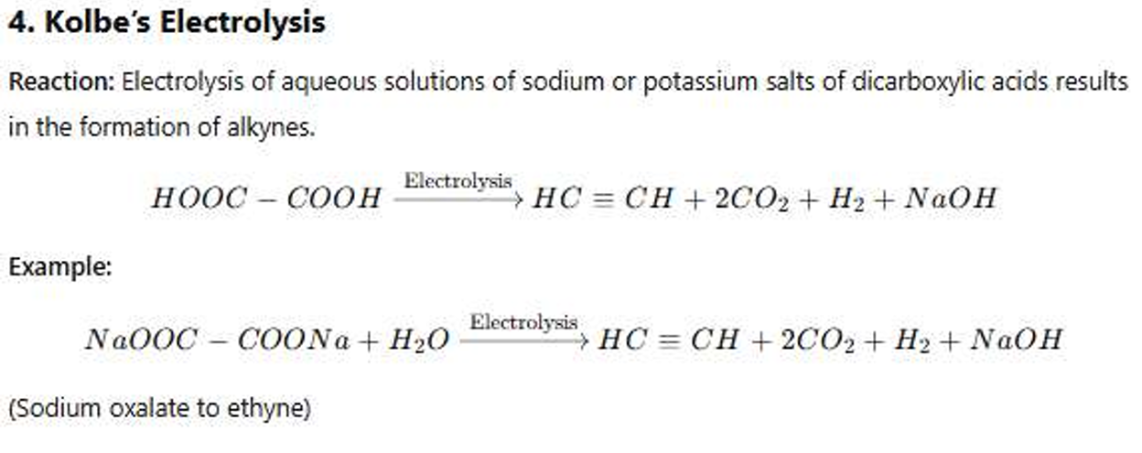
16]
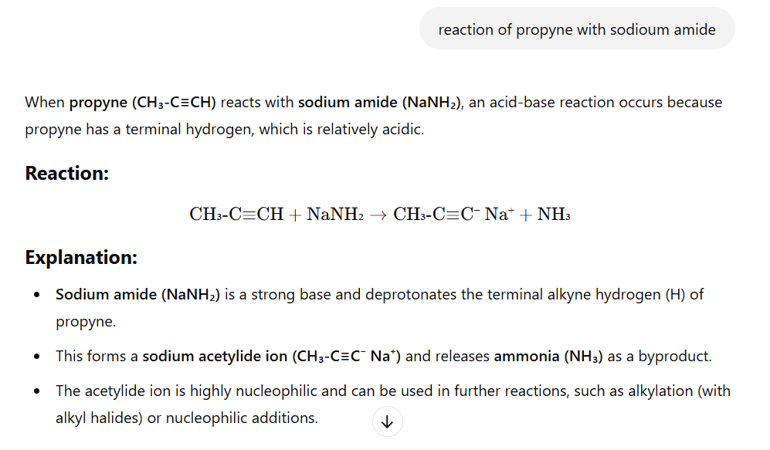
17] 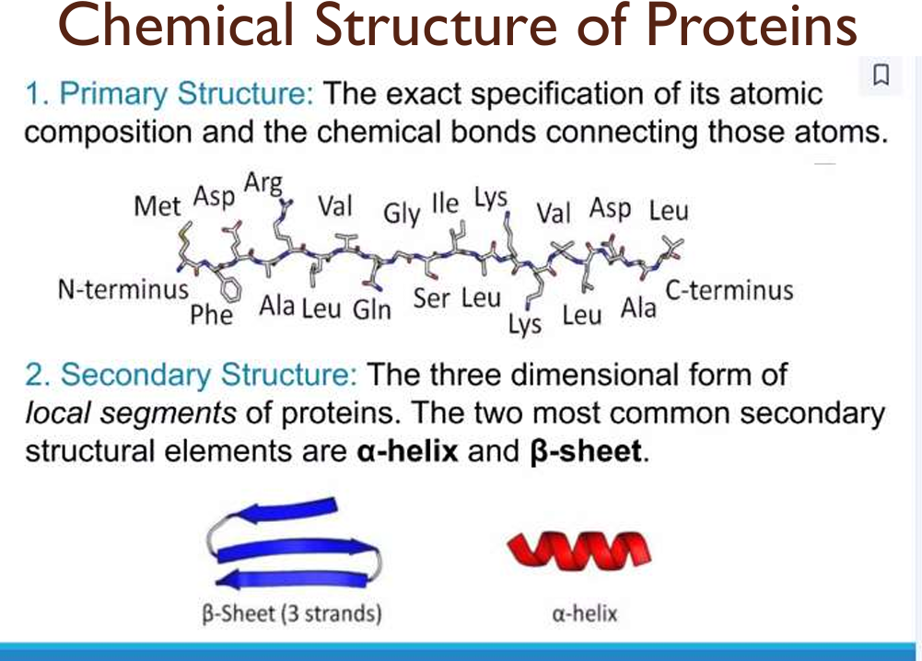
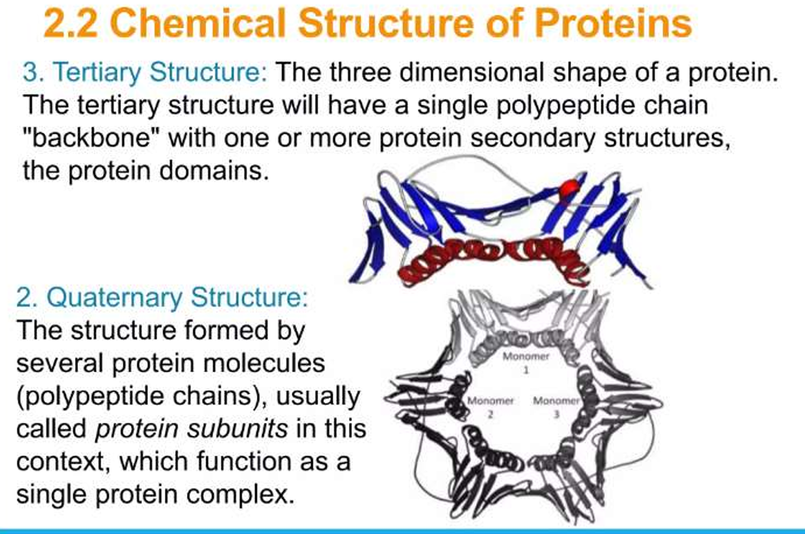
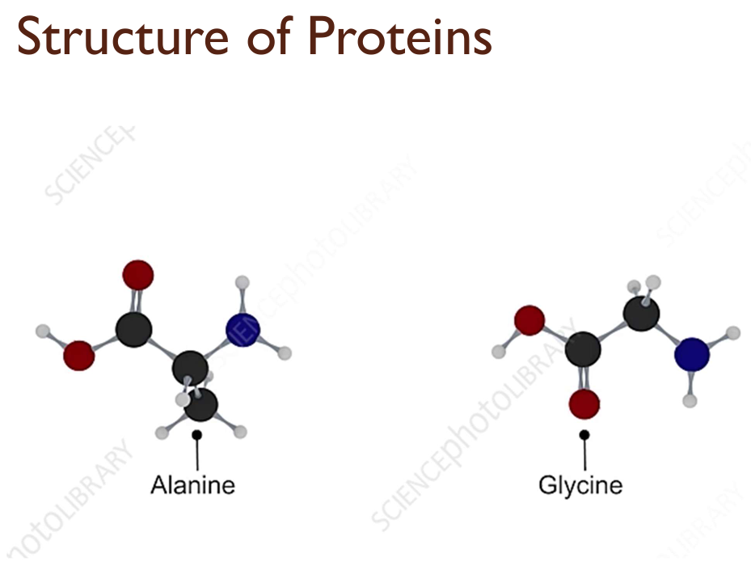
- Lyophilic Colloid - Solvent-Loving Colloid
The term "Lyophilic" comes from Greek, where "Lyo" means "to dissolve" and "Philic" means "loving." This refers to colloids that easily mix with the solvent and remain stable.
Characteristics:
- It is easily formed in a solution.
- It forms spontaneously.
- It is stable and does not coagulate easily.
- It does not break down easily even when heat or electrolytes are added.
- It mixes very well in aqueous solutions.

2. Lyophobic Colloid - Solvent-Fearing Colloid
The term "Lyophobic" means "fear of solvent," meaning these colloids do not mix easily with the solvent and remain highly unstable if they do.
Characteristics:
- It does not form easily and requires external energy.
- It is unstable and can coagulate.
- It can break down easily when electrolytes or heat are added.
- It has minimal interaction with the solvent.
😊

